Joel Ehrendreich Bio

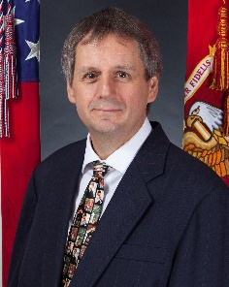

Joel Ehrendreich is a career member of the U.S. Foreign Service, Department of State. As of July 2022, he is serving as Director of the Office of Japanese Affairs.

Previously he served as Director of Regional and Security Policy in the Bureau of East Asian and Pacific Affairs. Prior to that, he was Senior Operations Officer in the Bureau of Legislative Affairs; Foreign Policy Advisor to the Commandant of the Marine Corps; Consul General at the U.S. Consulate General in Okinawa, Japan; Economic Counselor at U.S. Embassy Manila; Economic and Political Counselor at U.S. Embassy Singapore; Political-Military and External Unit Chief at U.S. Embassy New Delhi; Political Officer at Embassy Tokyo; Visa Officer in Sydney; and Consular and Political Officer in Togo, West Africa. He also served in the White House Situation Room as a Senior Duty Officer.

Joel graduated from Drake University in 1985 with a Bachelor of Business Administration degree. He served in the Peace Corps in Niger, West Africa 1985-87, and worked for several years in the private sector. His wife, Rachel, is also a Foreign Service Officer. They have two sons. His hobbies are watching baseball, playing baseball, and talking about baseball.

