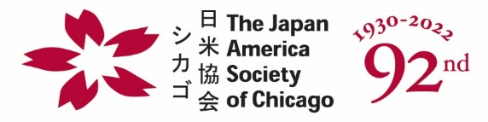

36th Annual Holiday Fundraiser & Bonenkai

December 7, 2022
Donation/Ad Form

To benefit programming and educational endeavors
Item/Cash/Ad Form (EIN# 36-2480811)
Credit Card Information:

Visa__
MasterCard__
Discover__
American Express __

Credit Card #:

Zip Code:
____________
Expiration Date (MM/YY)
___/___

Security Code
(3-4 Digit # on back of card):
____________

Ad Deadline:
Monday, November 14, 2022

Silent Auction Deadline:
Wednesday, November 30,, 2022
Contact Name:
Company Name:
Address:
Telephone: E-Mail:

CASH DONATION
Donation Type (Please Circle):
Check or Credit Card
Donation Amount (check enclosed):

SILENT AUCTION
Silent Auction Item Name & Description:
(__) I will Mail Item/Certificate to: Japan America Society of Chicago, 1 N LaSalle Street, #2475, Chicago, IL 60602
(__) I will E-Mail certificate to kono@jaschicago.org

Silent Auction Item Value (USD):
Program Booklet Credit:

AD IN HOLIDAY PROGRAM BOOK
Ad Payment Type (Please Circle): Check or Credit Card
Ad Size (Please Circle):
Inside Front Cover 4.6” x 7.5” (B&W $500) ( ) (Color $700) ( )
Full Page 4.6” x 7.5” (B&W $350) ( ) (Color $550) ( )
Back Cover 4.6” x 7.5” (B&W $600) ( ) (Color $800) ( )
Inside Back Cover 4.6” x 7.5” (B&W $500) ( ) (Color $700) ( )
1/2 Page 4.6” x 3.5” (B&W $300) ( ) (Color $500) ( )
1/3 Page 4.6” x 2.25” (B&W $200) ( ) (Color $400) ( )

* All ads should be provided as a high resolution PDF file. Please submit ads via email to kono@jaschicago.org no later than Monday, November 14.

Japan America Society of Chicago

One North LaSalle Street, Suite 2475, Chicago, IL 60602

(312) 263-3049 ext. 25; Fax: (312) 263-6120; E-Mail: kono@jaschicago.org

